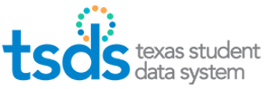

TSDS Parallel TIMS Tickets

The TSDS Incident Management System is used to track TSDS issues. From the Support link, districts may search Knowledge Based articles, submit an incident, or view incidents that have been previously submitted.

- Log into TEAL.
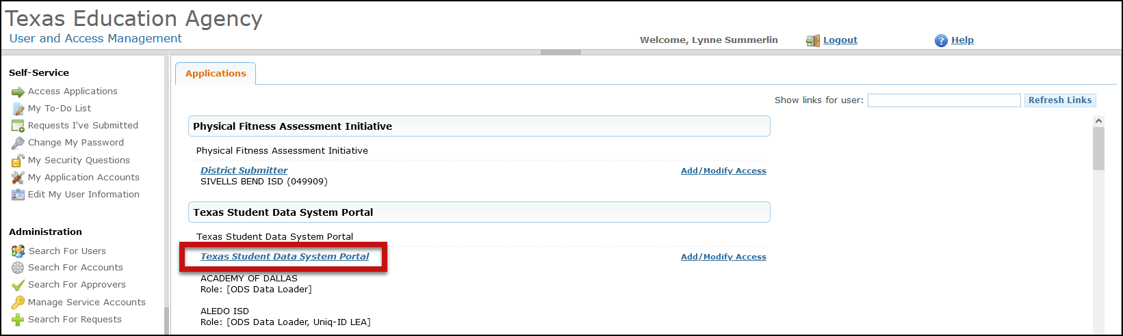
- Click on Texas Student Data System Portal link.

- Click on Support.

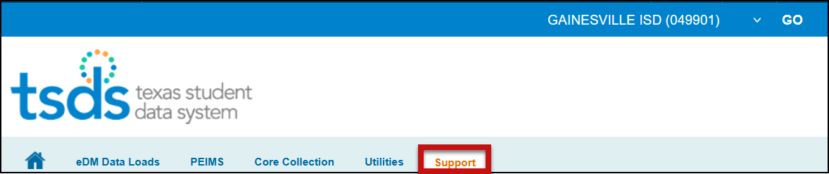

- To enter or view a ticket, click on Submit & View Incidents.

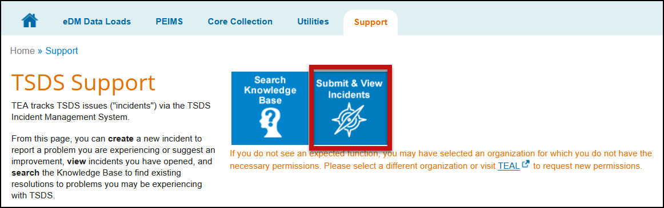

- Click Create.
- Enter the information as it applies to the issue experienced. Select TSDS Upgrade Project for the Subsystem and the component the issue relates to.

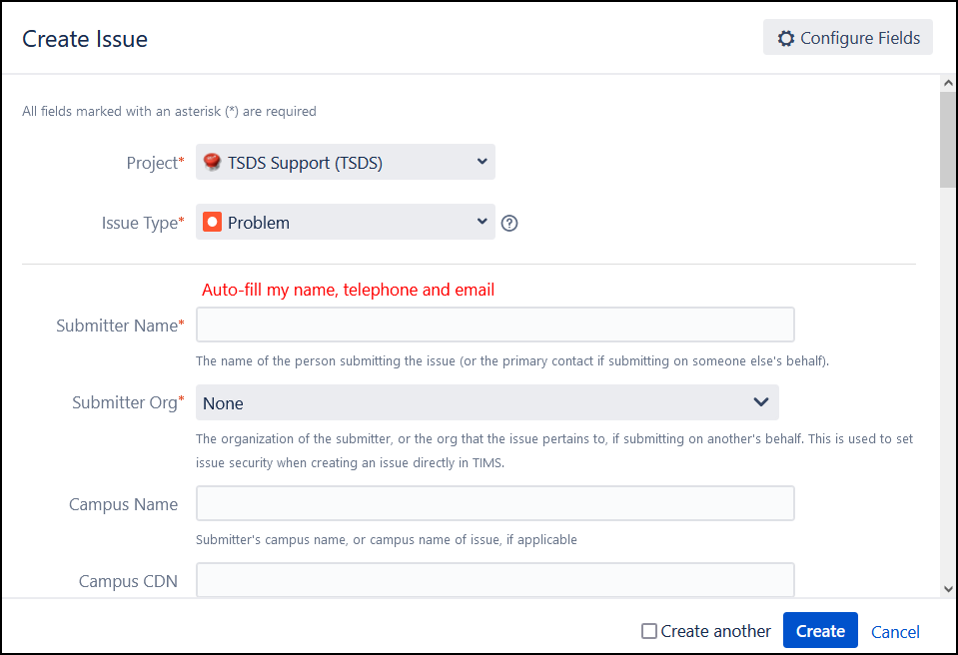

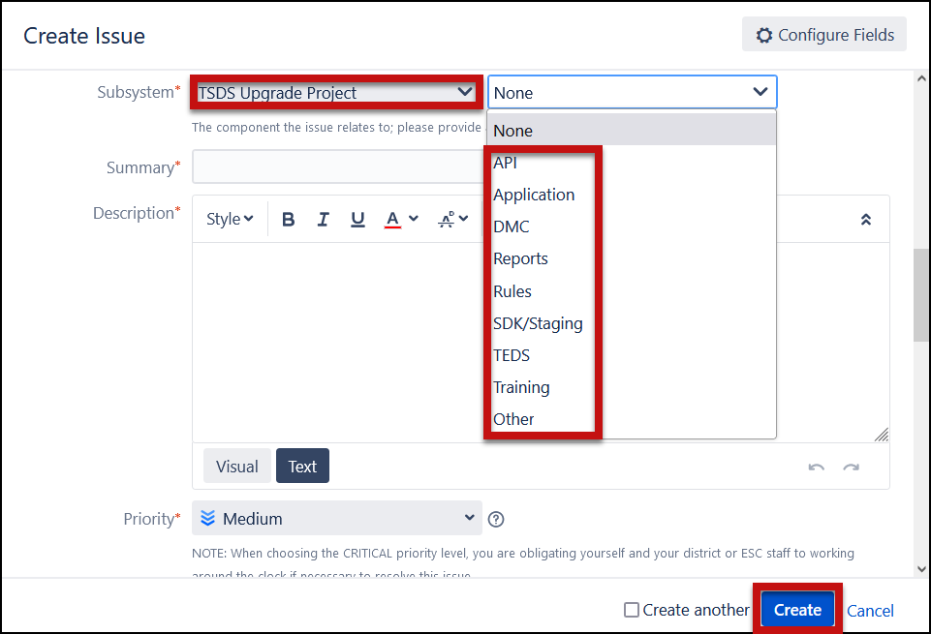

- Click Create.
- Escalate the ticket to Level 2 – ESC Region 11.

Category Guidance for TSDS Parallel TIMS Tickets

API – Use to report configuration or connectivity issues

Application – Use to report PEIMS or Core application issues, such as promotion errors

DMC – Use to report issues with Key/Secret, Level 1.5, or Level 2 Validations

Reports – Use to report PEIMS or Core report issues

Rules – Use to report PEIMS or Core rule issues

SDK/Staging – Vendors Only use to report issues with the SDK or Staging environment

TEDS – Use to report issues with the data standards or to request clarification on reporting requirements

Training Materials – Use to report issues with training materials or provide feedback

Other – Use for all other issues that do not fall within one of the above categories

